Reports

There are some out of the box reports like (campaign performance…)

In the Reports entity there are many available reports

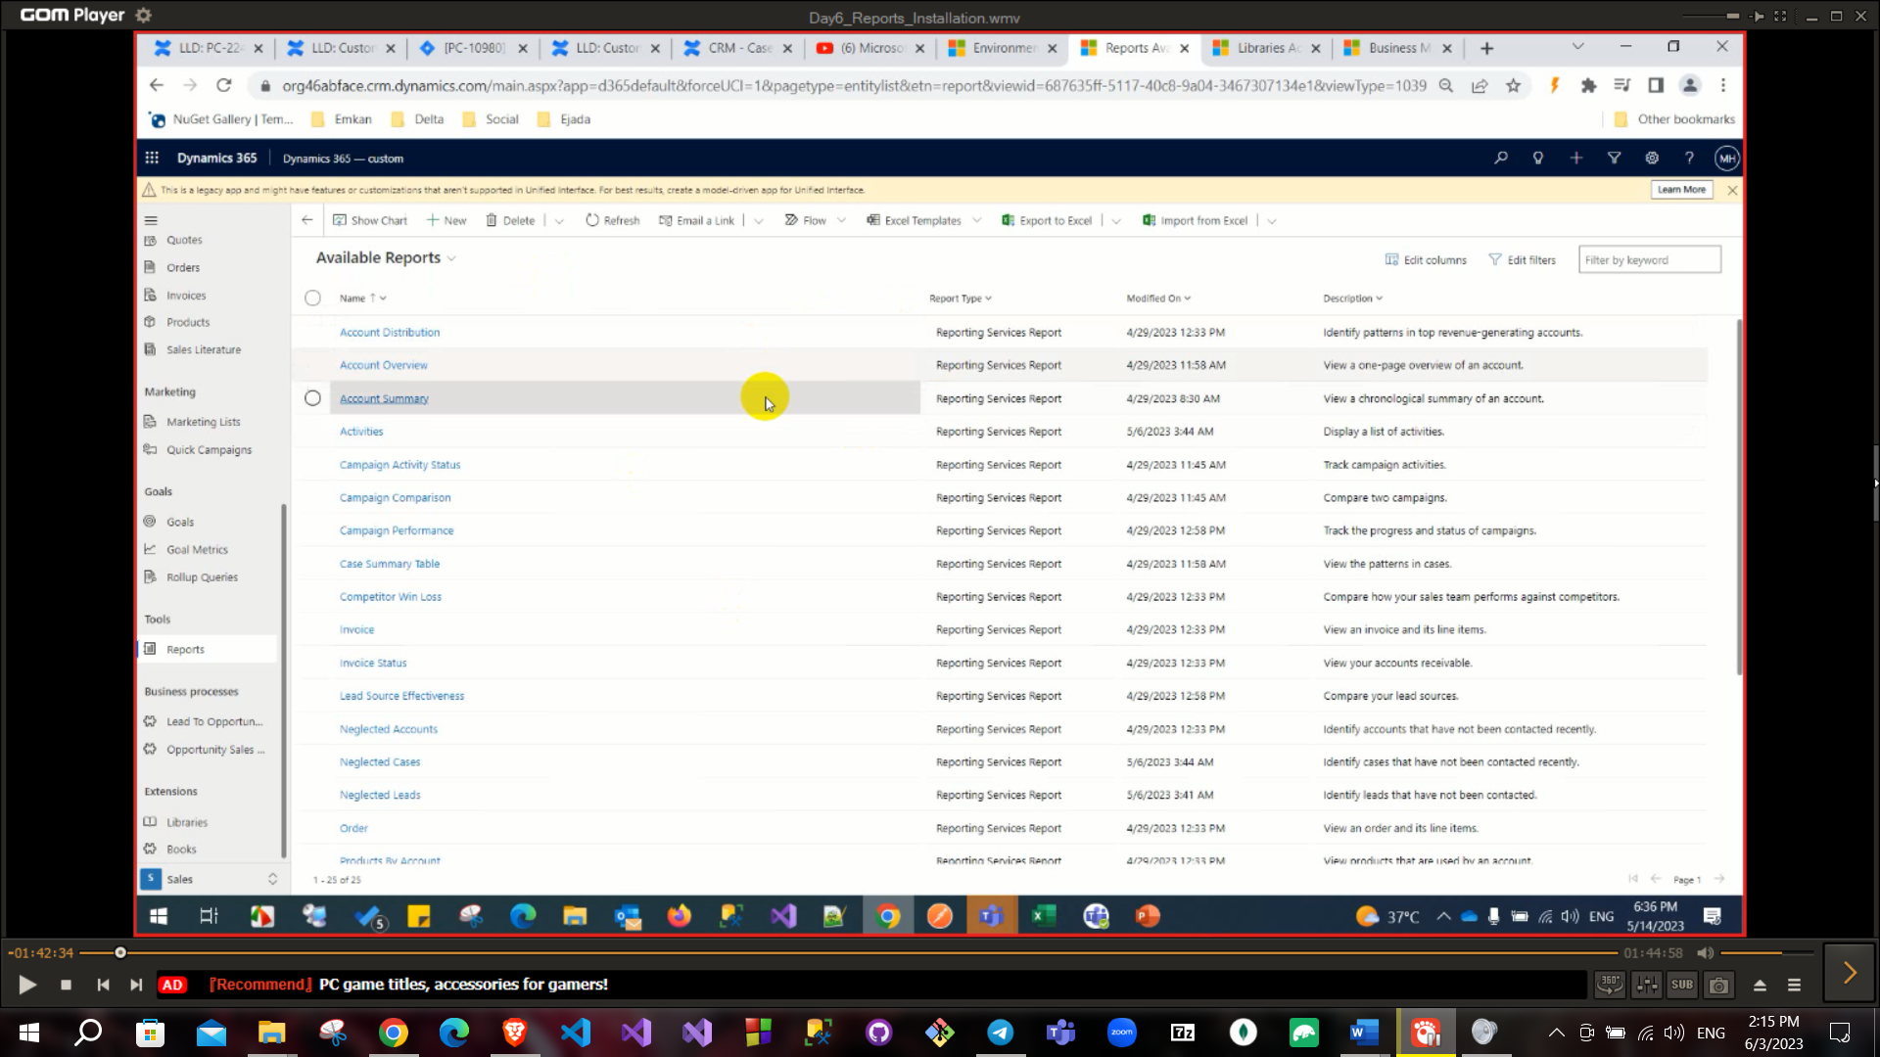

To create report from tools reports click new at the ribbon

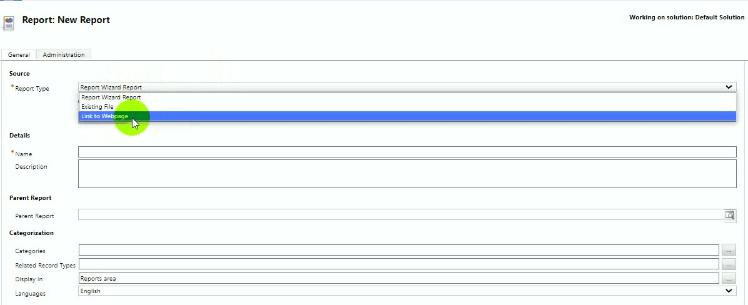

Report wizard or from existing file (build your report in VS it has .rdl extension) or Link to webpage to integrate with external report.

Wizard report straight forward steps but has low level of customization

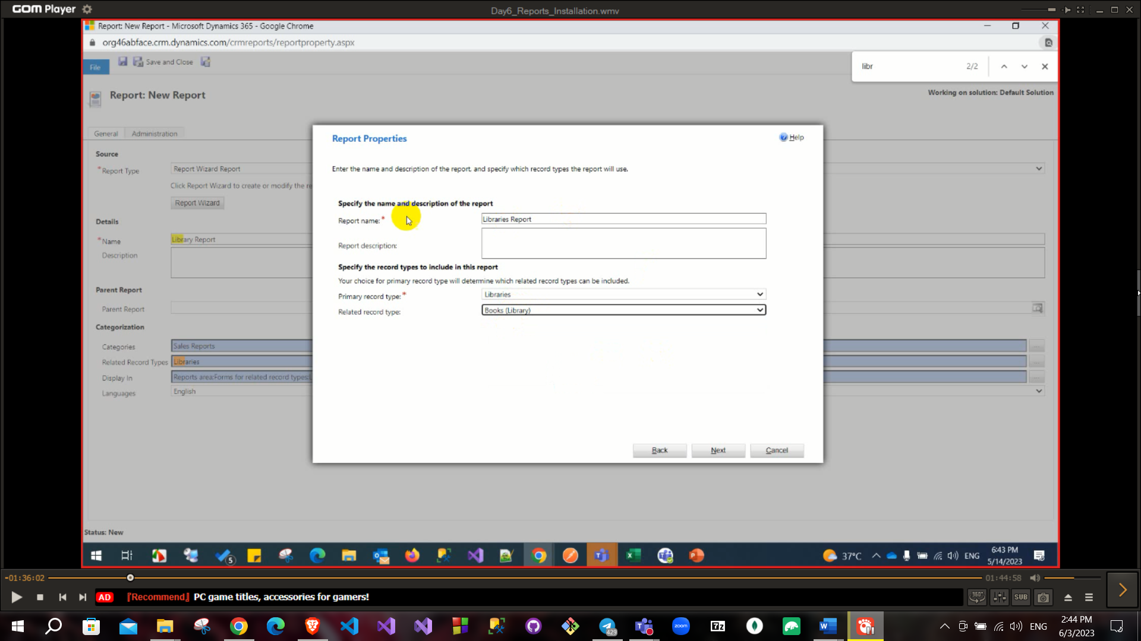

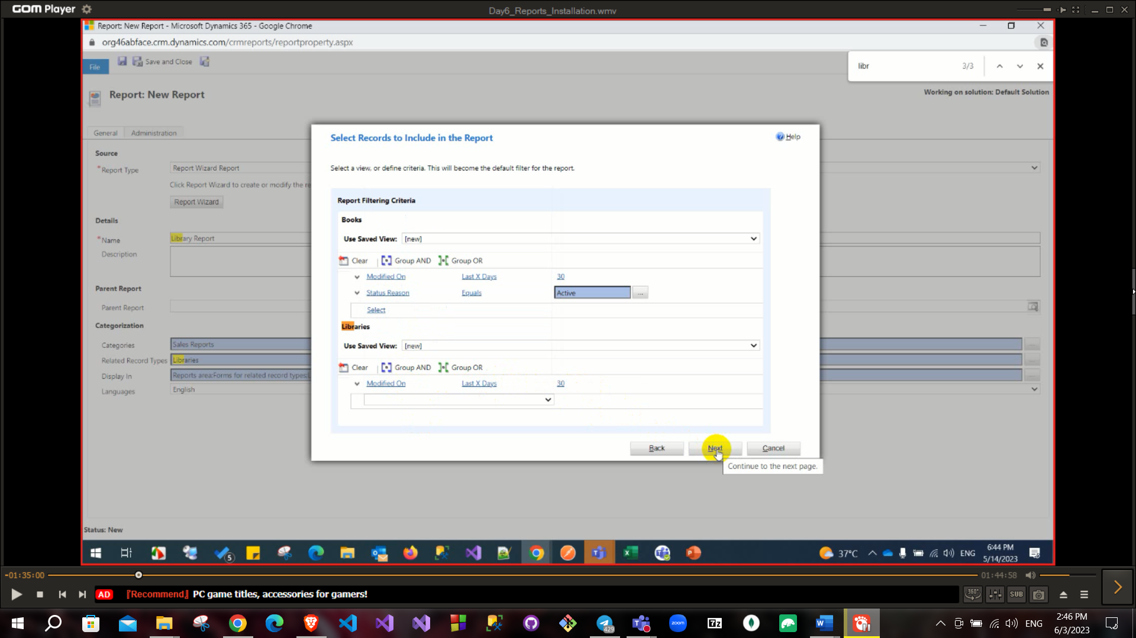

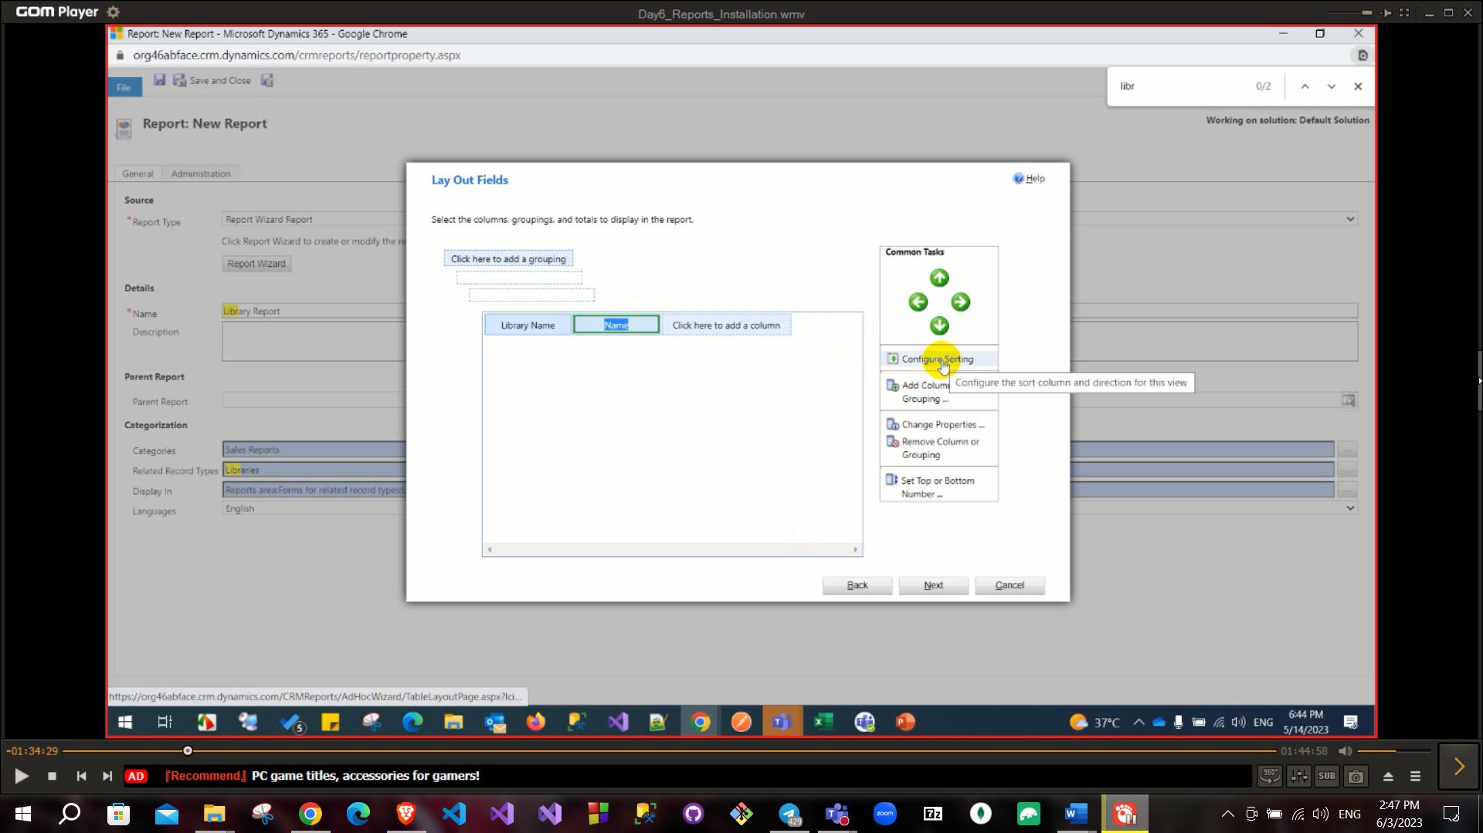

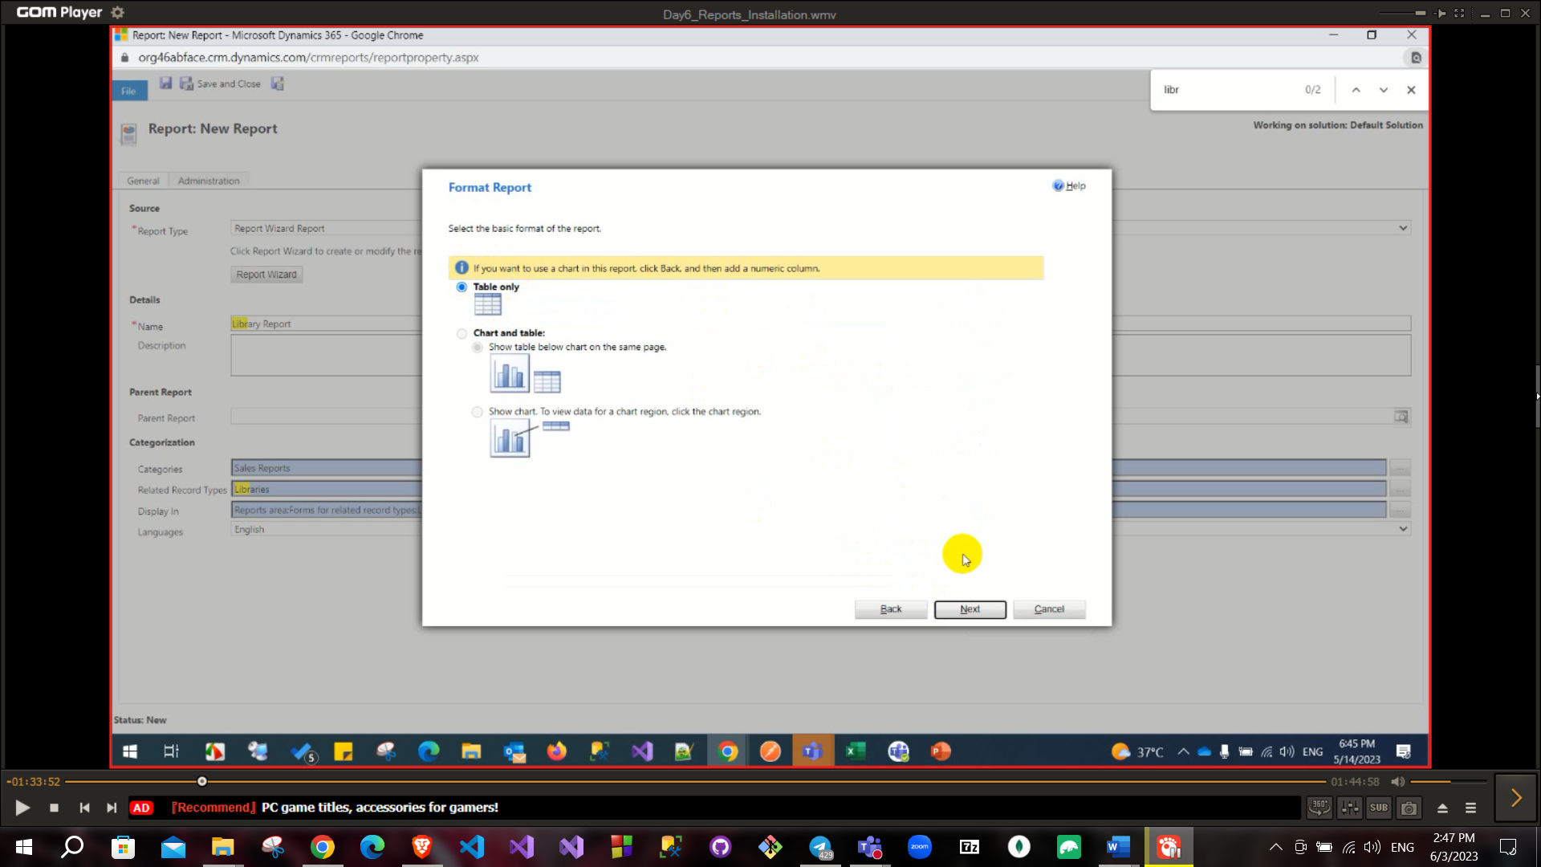

Click on Run Report above

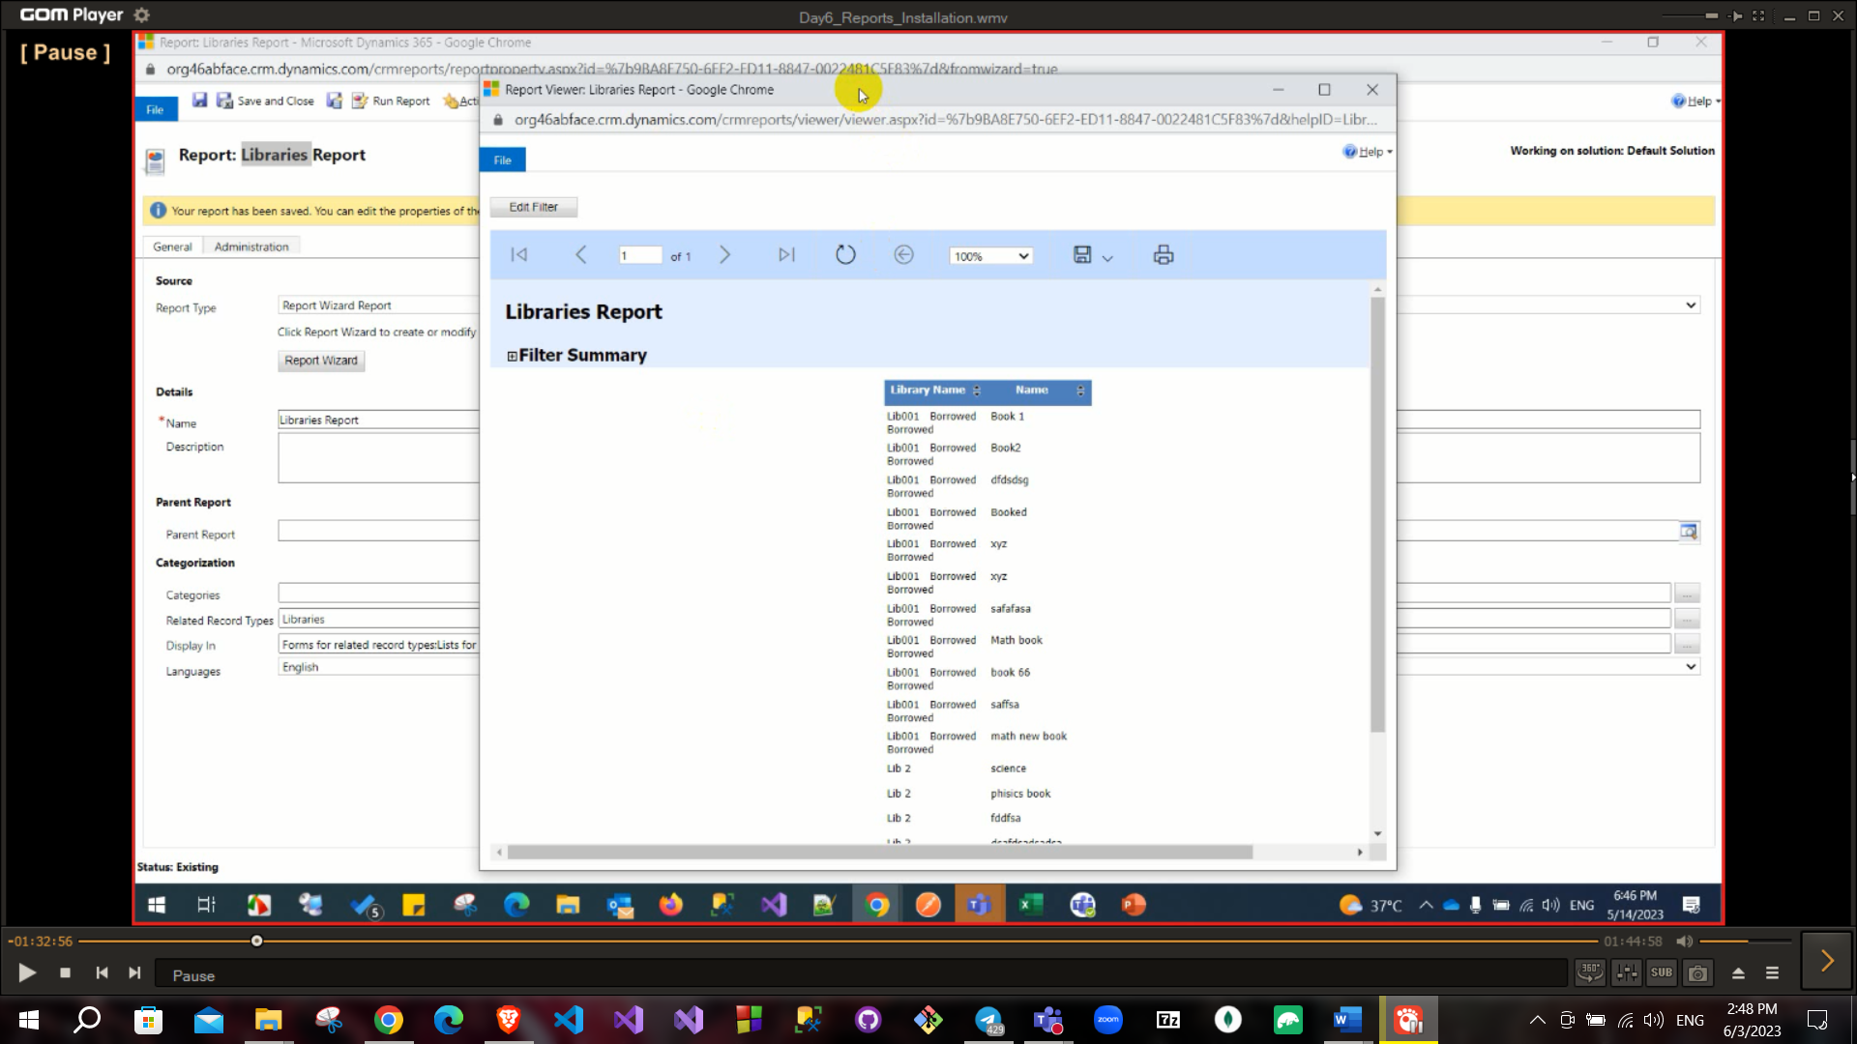

To create a customized report from SSRS tool and add this report to environment (create report project from VS)

Install Data storage

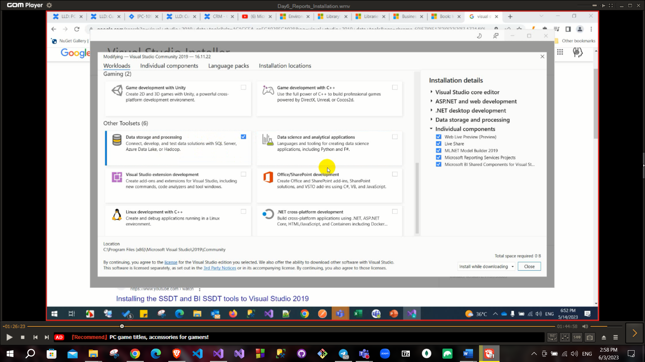

Choose Project template and create

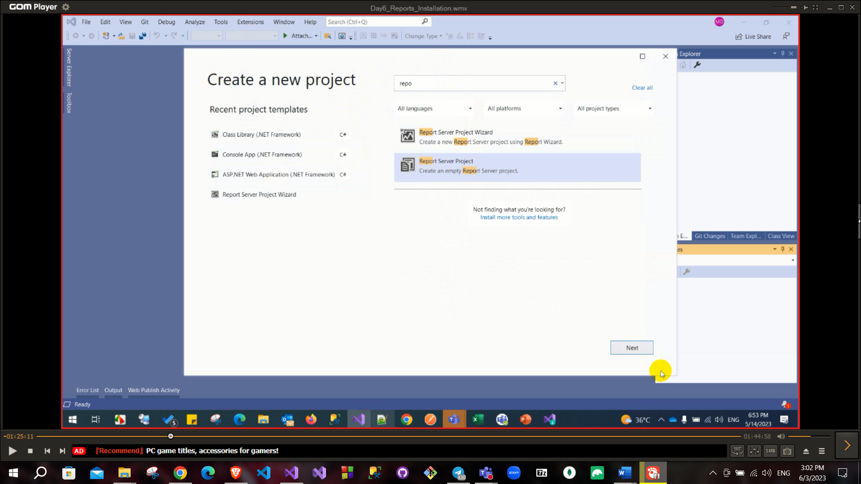

Then add datasource

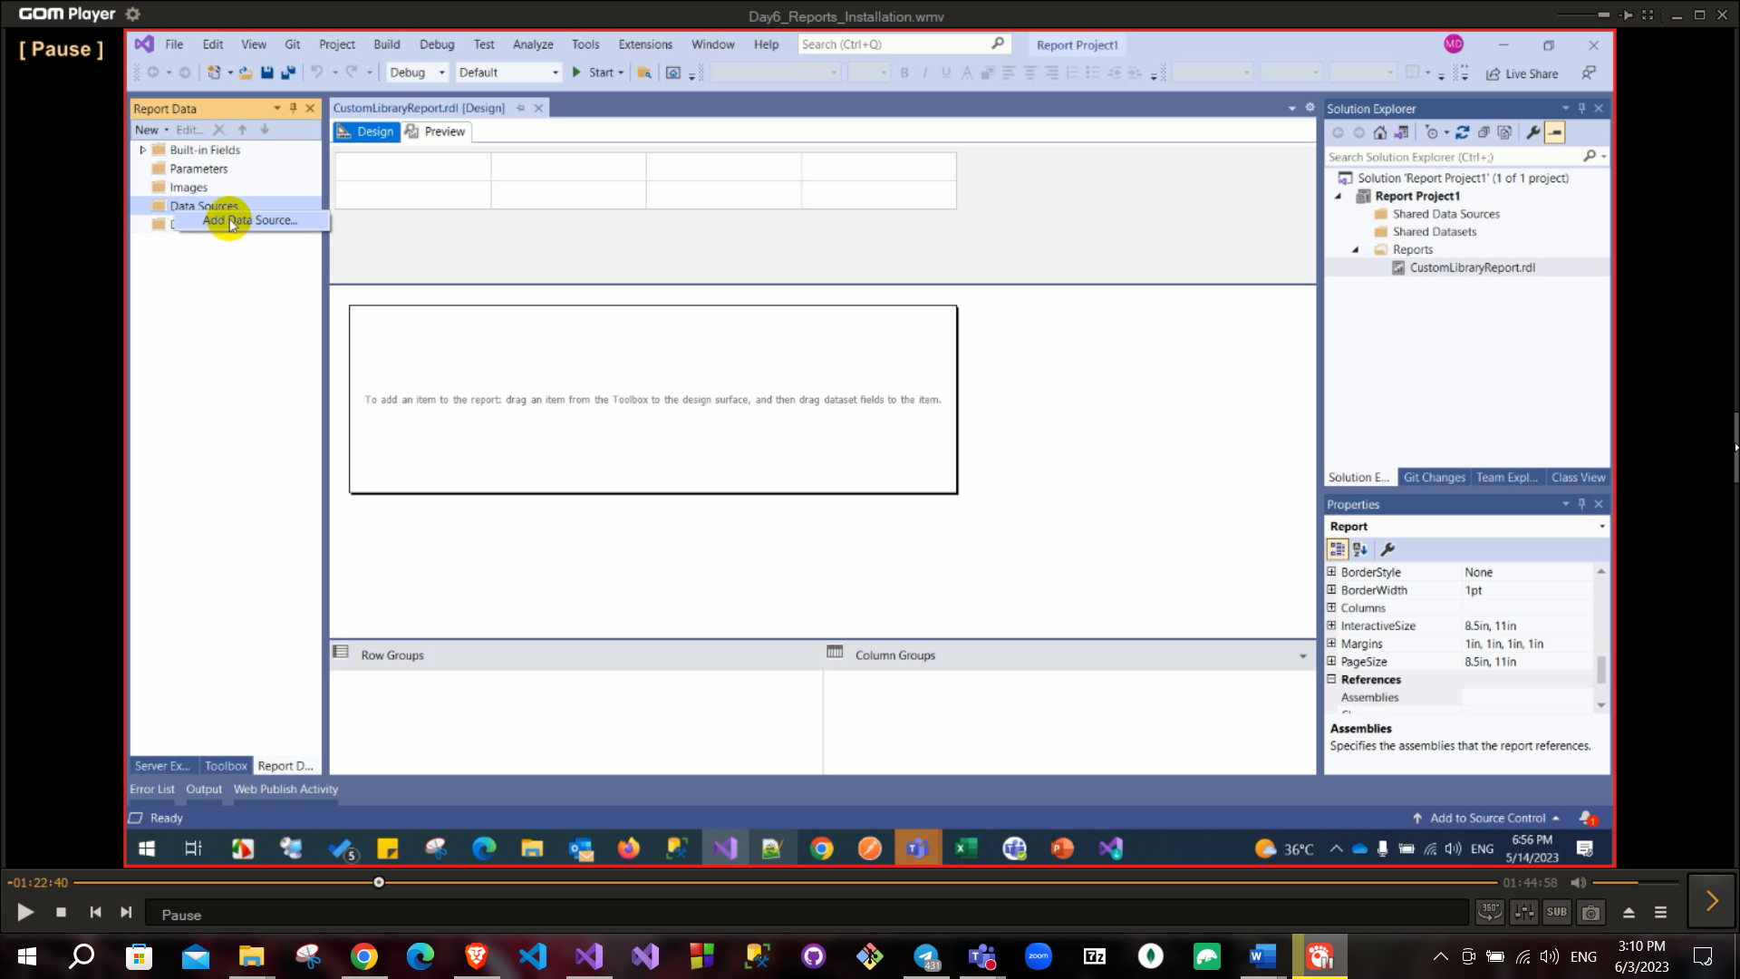

To connect data source of SSRS with database of dynamics CRM you need to install Microsoft dynamics 365 reporting Authoring Extension

So, after installing this extension you will able to select **Microsoft dynamics 365 Fetch** from data source in reporting tool.

Connection string here is base URL of organization and credential (user name and password are user name of dynamics account and its password)

Also, dataset here must be **Fetch xml** so you can use advanced find in this case.

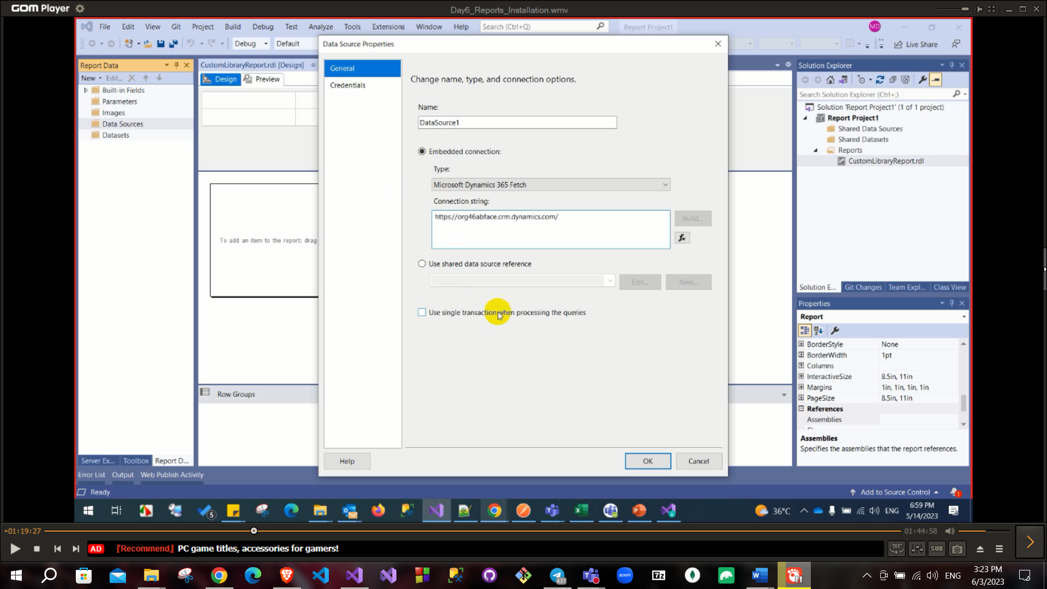

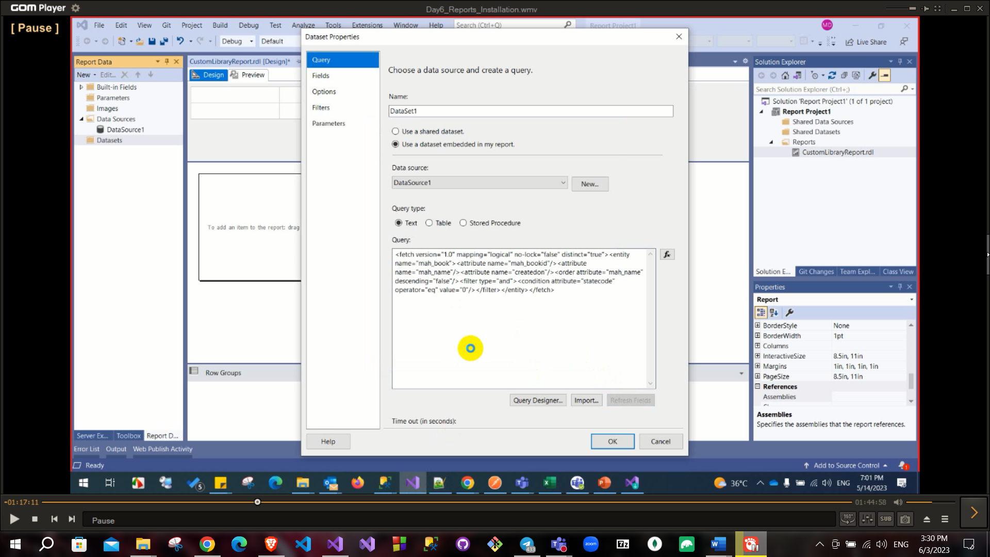

To get the fetchXml from the crm

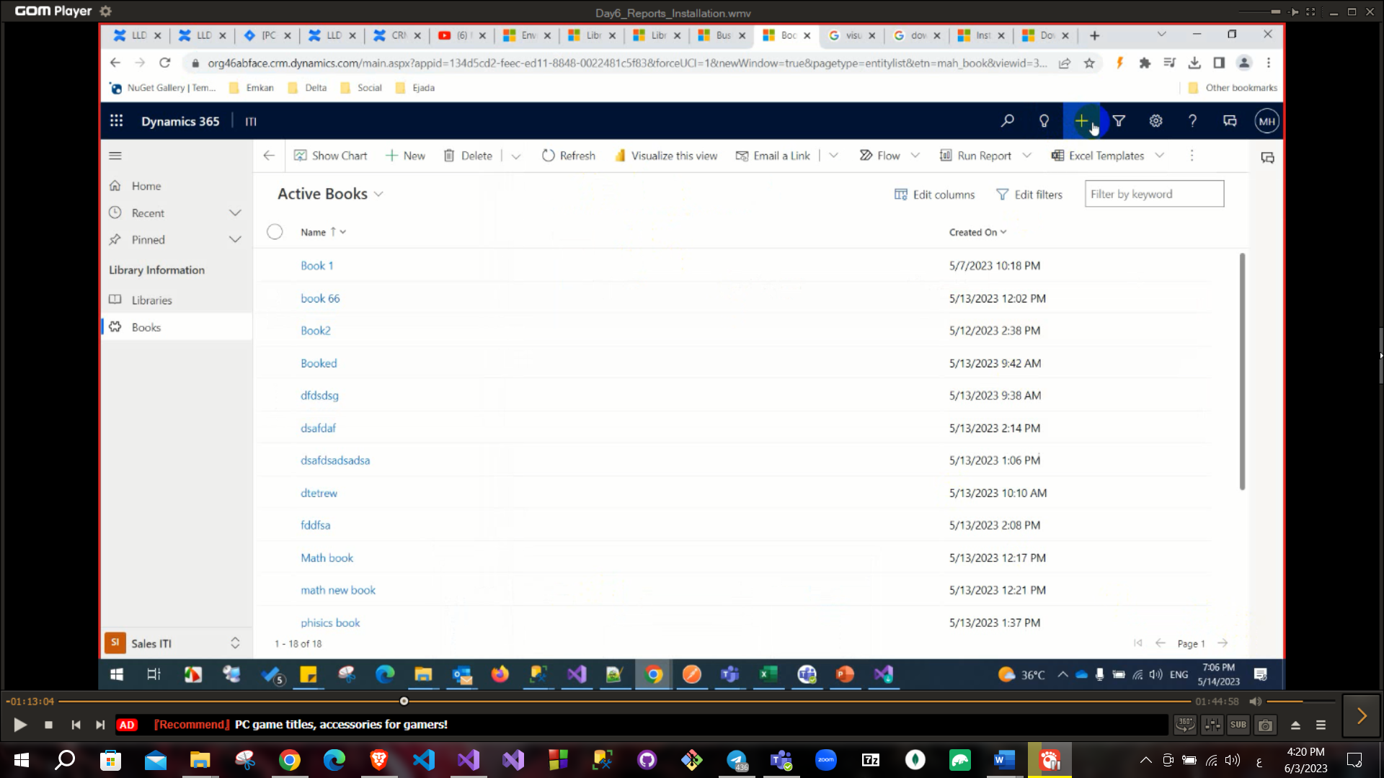

And choose the entities you want to fetch and click fetchXML

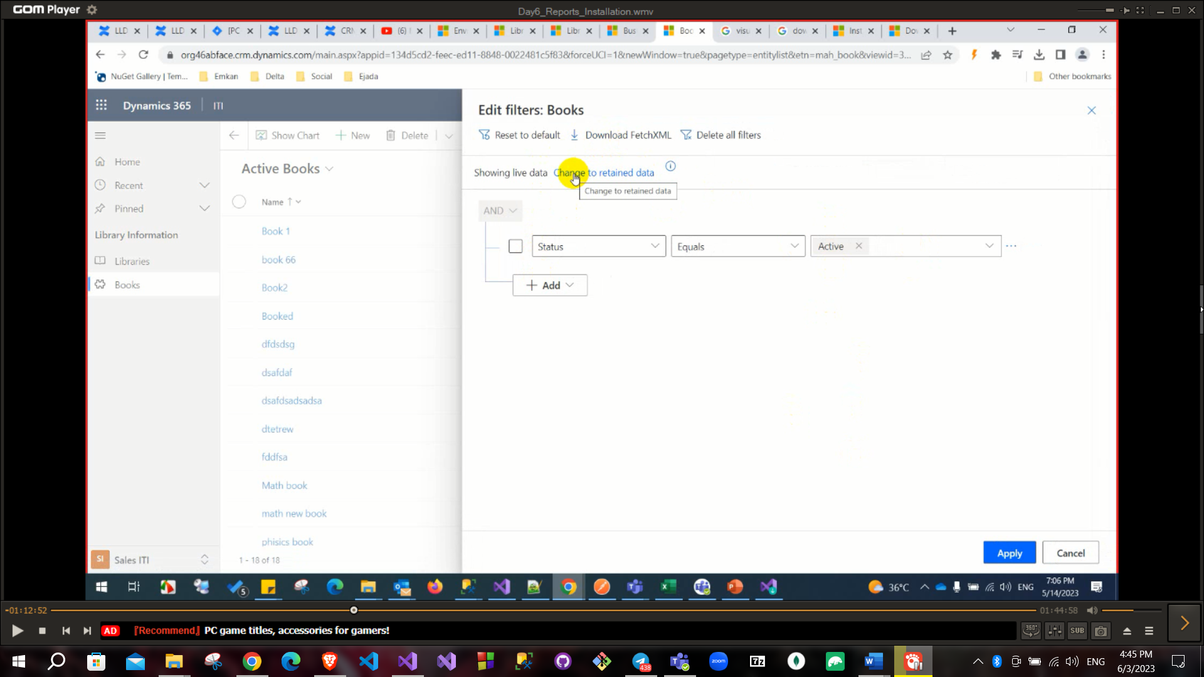

After customizing the report as you want build the solution and go to the bin folder and use the rdl file

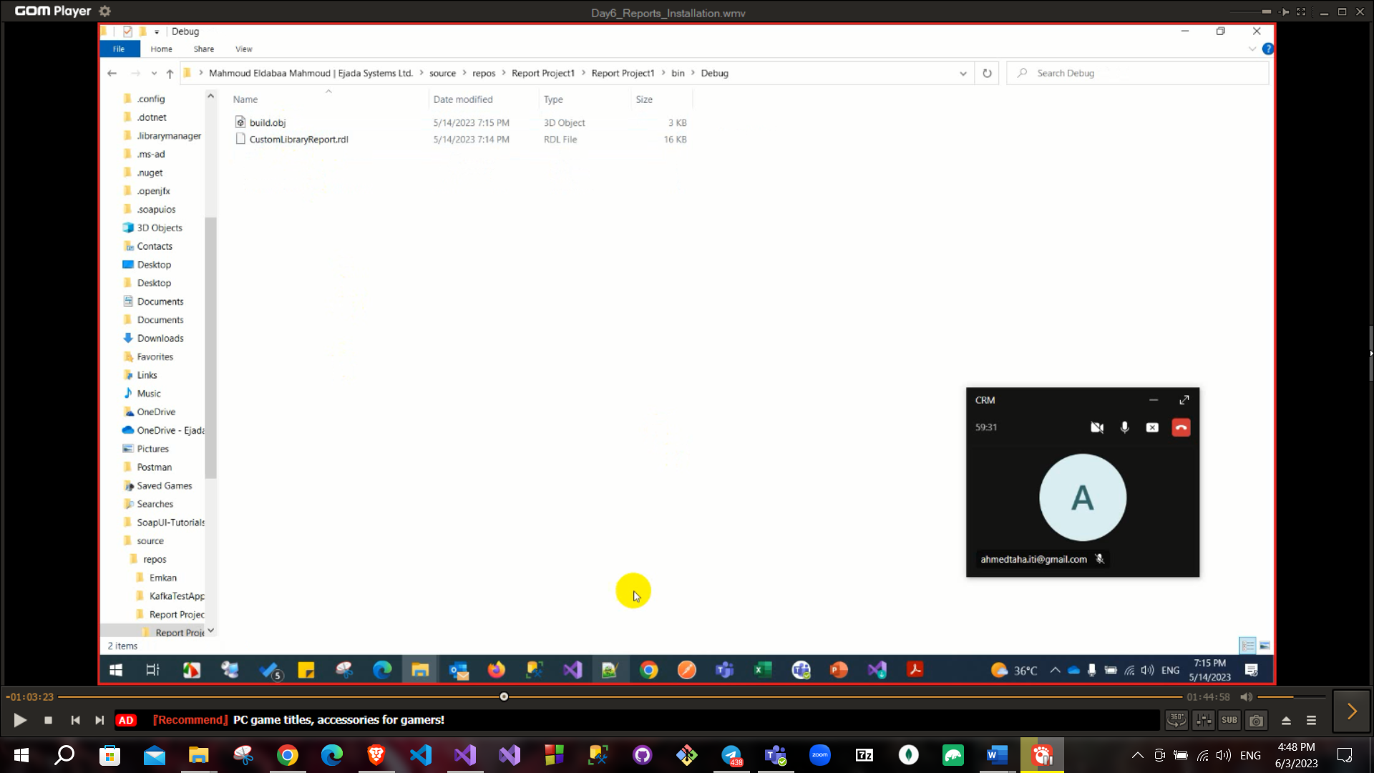

To add the report add new report and choose existing report

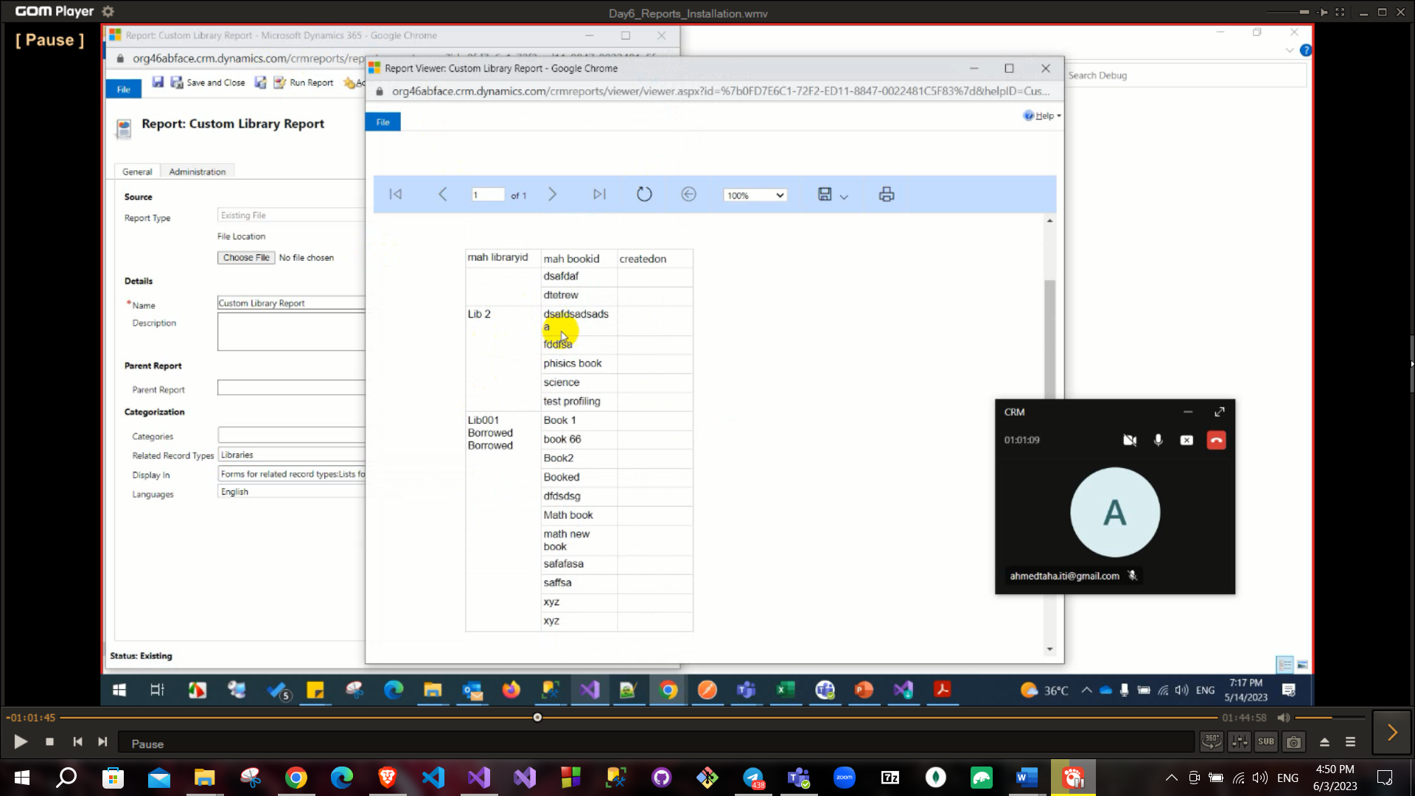

If you are using crm on prem you can use fetch or sql

You can download the on prem crm to your server

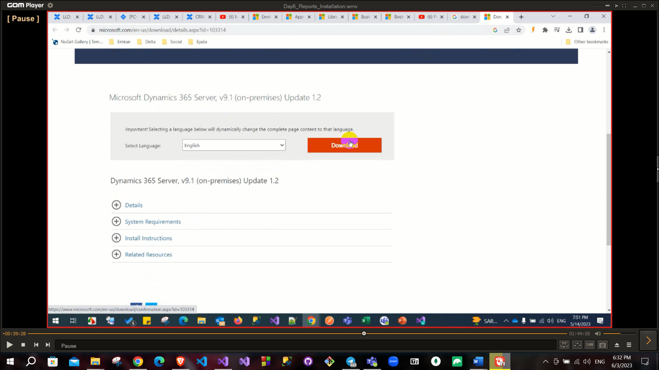

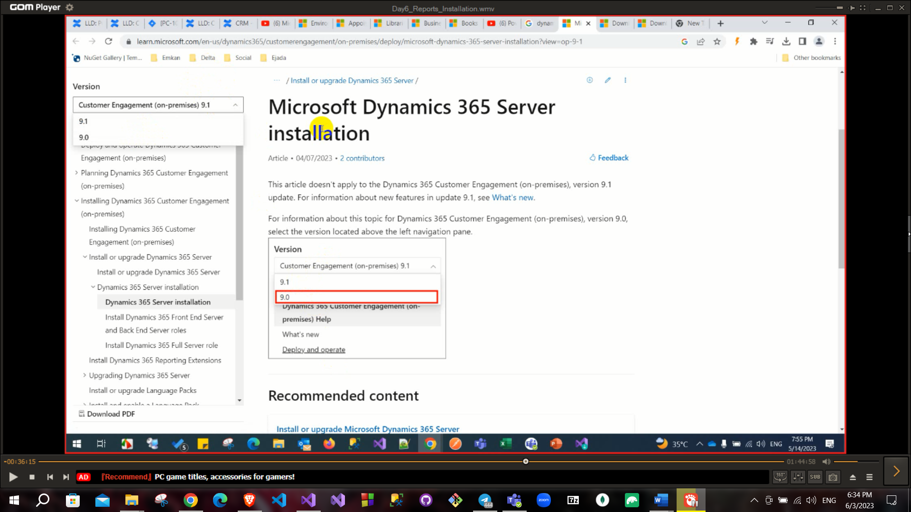

Recover some points

From activity → appointment (you can create appointment to set it as a daily or rescheduled …) it is called Recuring appointment, it found in services

If I want to connect crm from console app

I can make the xrm tool make the connection string for me

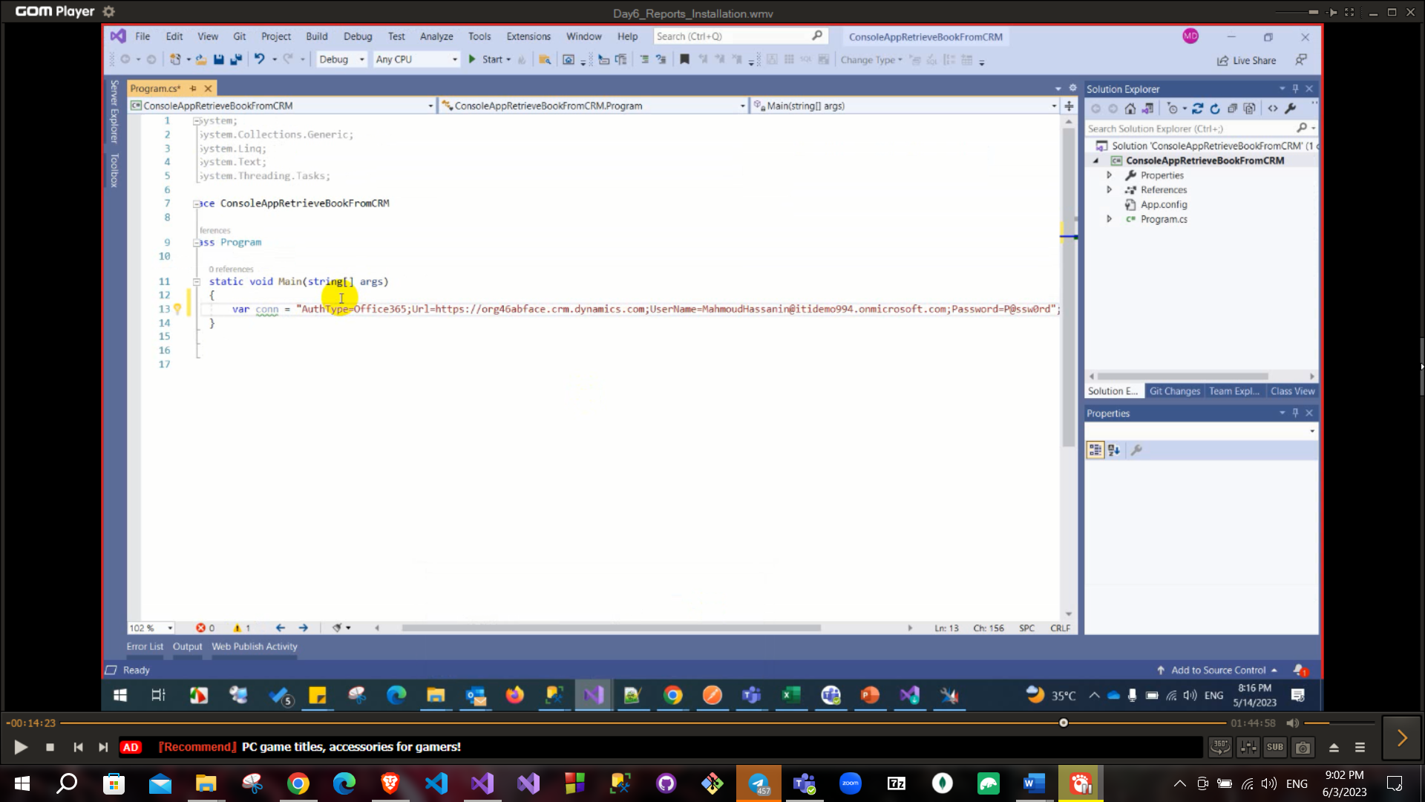

Then Install the packages dynamic.crmsdk.coreAssemblies

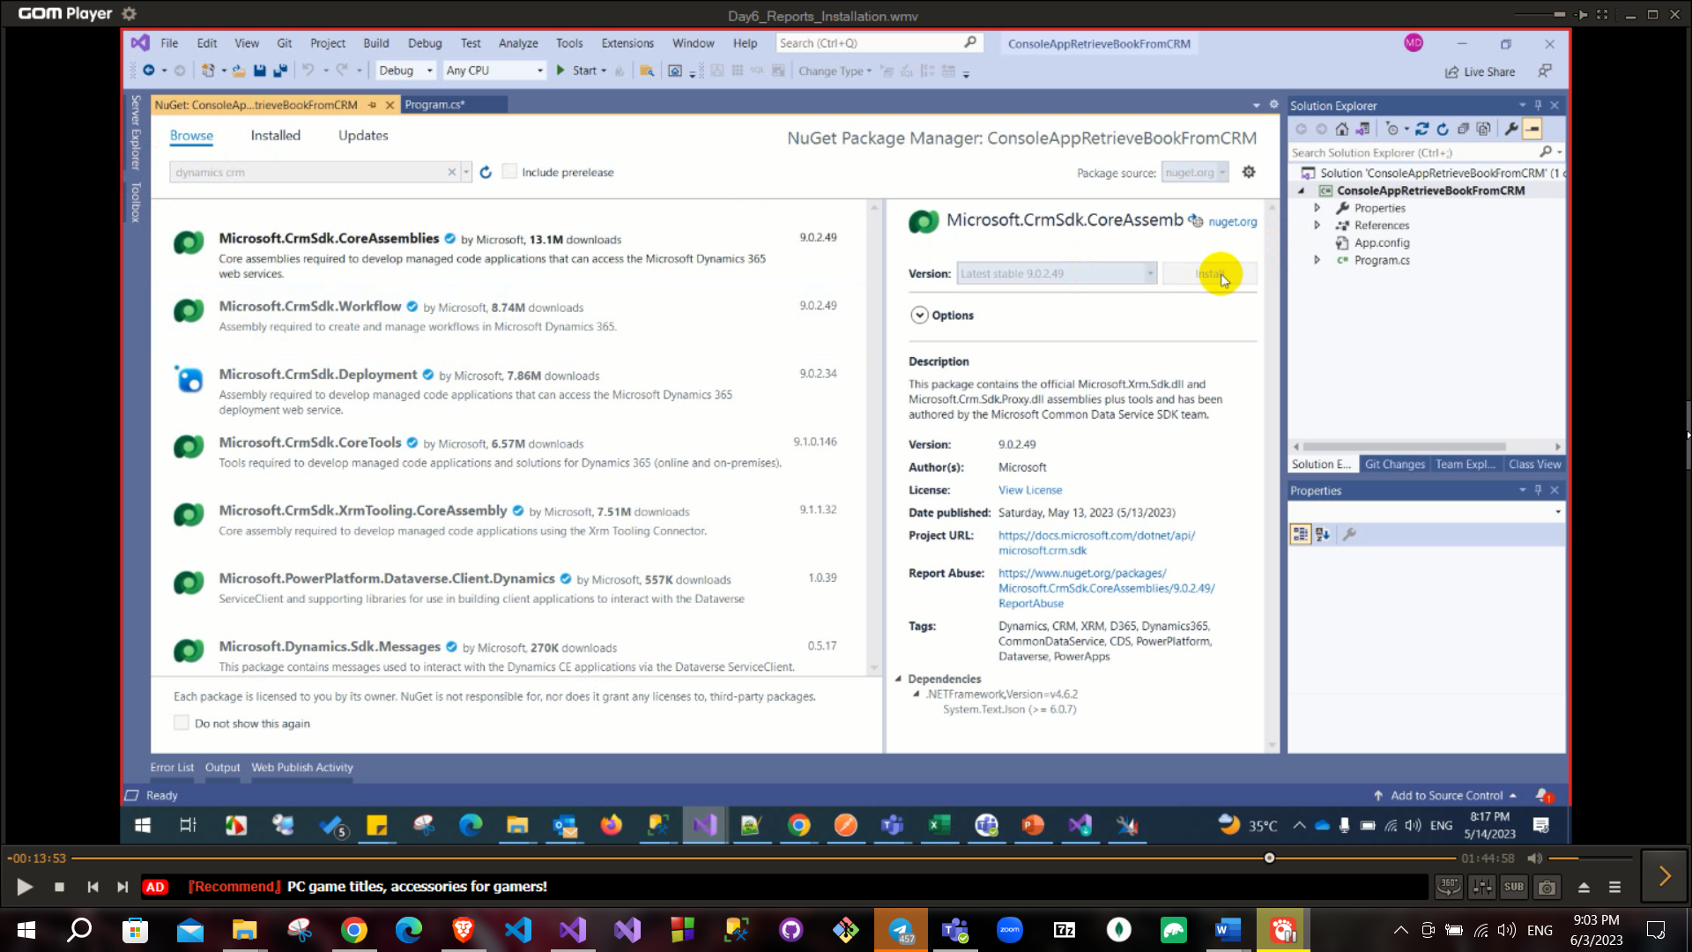

And the other packages

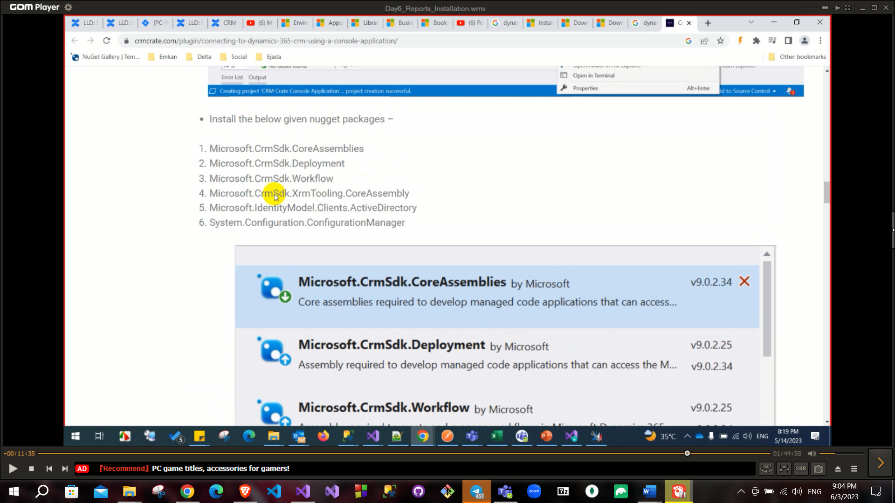

Now you are connected and free to continue retrieve the data

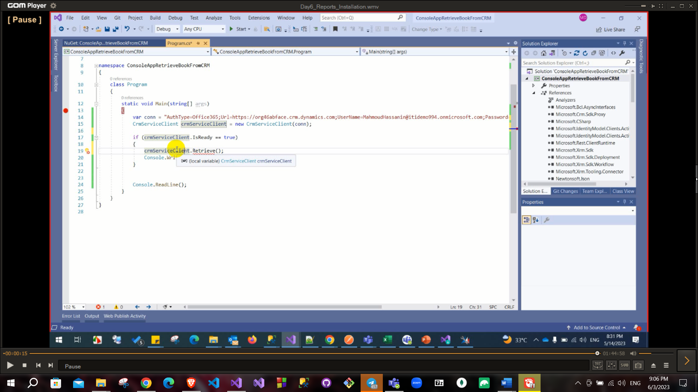

Sales

1. What is CRM?
2. What is XRM?
3. What are modules in dynamics 365?
   1. Sales
   2. Marketing
   3. Customer services
   4. Field services (online)
   5. Project services (online)
4. Sales cycle from lead to invoice.
5. What are order statuses?
6. What are invoice statuses?
7. Could you add quotation without opportunity?
8. Cloud you add product without pricelist?
9. What is pricelist?
10. What is pricelist item?
11. What is discount list?
12. What is product, product family, product bundle and unit group?

Marketing and services

1. What is difference between campaign and quick campaign?
2. What is marketing list (static and dynamics) and difference between them?
3. What is campaign response, could you convert to opportunity?
4. What is routing rule?
5. What is difference between queue and team?
6. What is case, subject, entitlement, SLA and knowledge base?

Administration

1. What is team?
2. What is difference between team and access team?
3. What is security rule?
4. What are levels of security rule?
5. What are permissions on security rule?
6. What is difference between append and append to?
7. What is field security?

Customization

1. What is entity ownership?
2. What is virtual entity?
3. What is difference between option set and global option set?
4. What are types of fields?
5. What are types of relationships?
6. What are relationship behaviors and difference among them?
7. What is business role and his scope?
8. What is difference between JS and business role and which run at the first?
9. What are types of processes?
10. What is difference between workflow and action?
11. What is dialog?
12. What is business process flow?
13. What is difference between workflow and plugin and when use each of them?
14. What are report types?
15. How can I create custom report?
16. How can I connect with CRM to create custom report?
17. What is SDK message?
18. What are plugin images?
19. What is isolation mode in plugin?
20. What is plugin pipeline?
21. What are workflow messages?
22. What are plugin messages?
23. How can I debug plugin execution?
24. How can I debug workflow execution?
25. How can I edit in side map, UCI, ribbon?
26. What is formContext and Xrm.page in JS?
27. What are form events (onLoad, onSave)?
28. How can stop normal behavior of event (using preventdefaultbehavoir method)?